Mack Hall

2/7/19

ECE 342 - Blue 1 | AC Bluetooth Switch

Prof. Shuman

Interface & Property Definition Table for ACS722LLCTR-40AU-1 Current Sensor

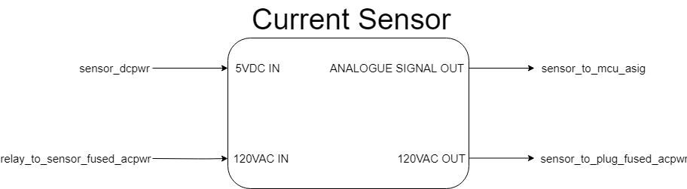

**Fig. 1.** Black Box Diagram of Current Sensor Block

**Table 1.** Current Sensor Block Interfaces and Properties

|  |  |
| --- | --- |
| Interface | Properties |
| sensor_dcpwr | VMin: 3VDC  VNominal: 3.3VDC:  VMax: 3.6VDC  INominal: 9mA  IMax: 12mA |
| sensor_to_mcu_asig | VMax: 6 VDC  VNominalLow: 0.36 VDC  VNominalHigh: 5 VDC  VMin: -0.5 VDC  tRise: 4㎲  tResponse : 5㎲  tProp: 1㎲ |
| relay_to_sensor_fused_acpwr | VNominal: 120VACRMS  IMax: 5A  IMin: -5A  fNominal: 60Hz |
| sensor_to_plug_fused_acpwr | VNominal: 120VACRMS  IMin: -5A  IMax: 5A  fNominal: 60Hz |

**Fig. 2.** High Level Block Diagram of AC Bluetooth Switch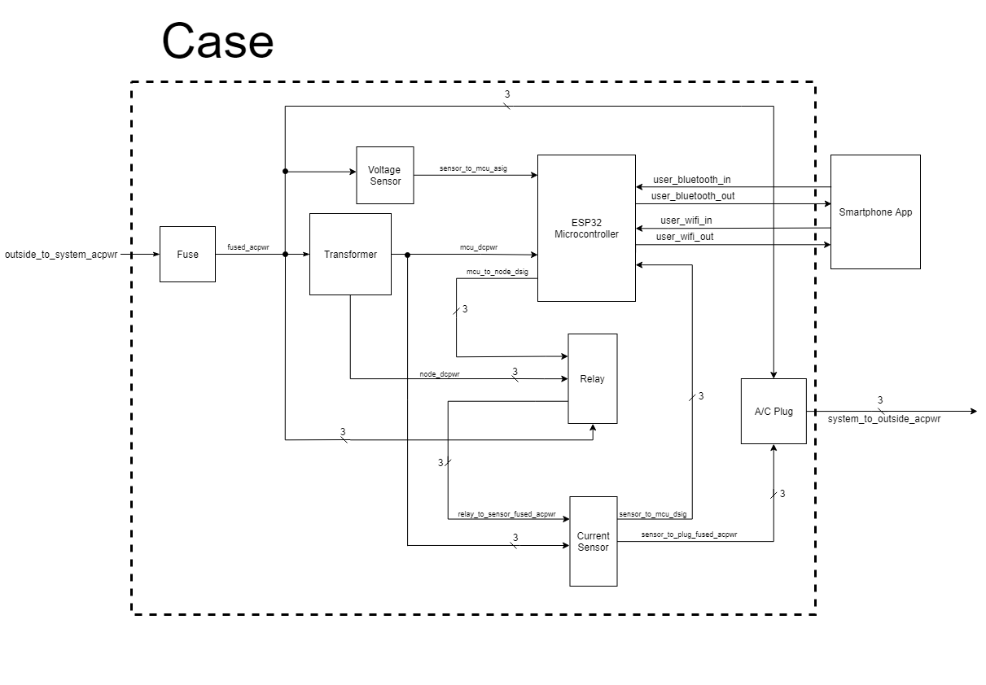

**Fig. 3.** Schematic for Current Sensor Connections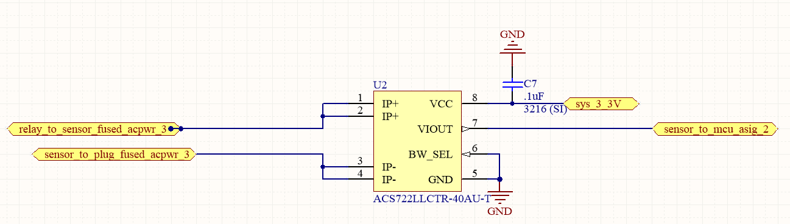

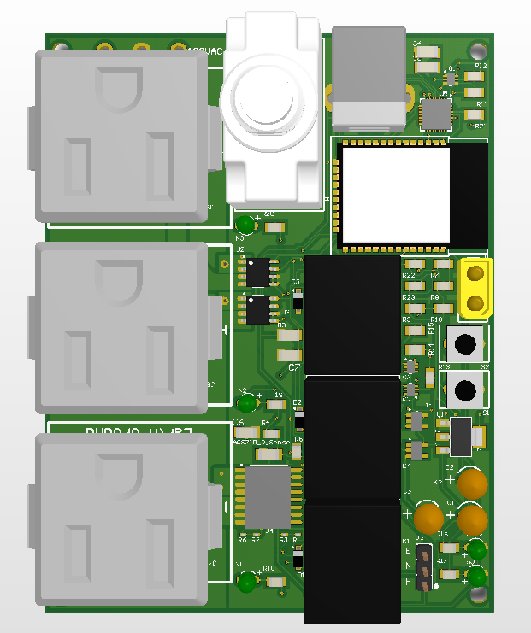

**Fig. 4.** A Render of the PCB

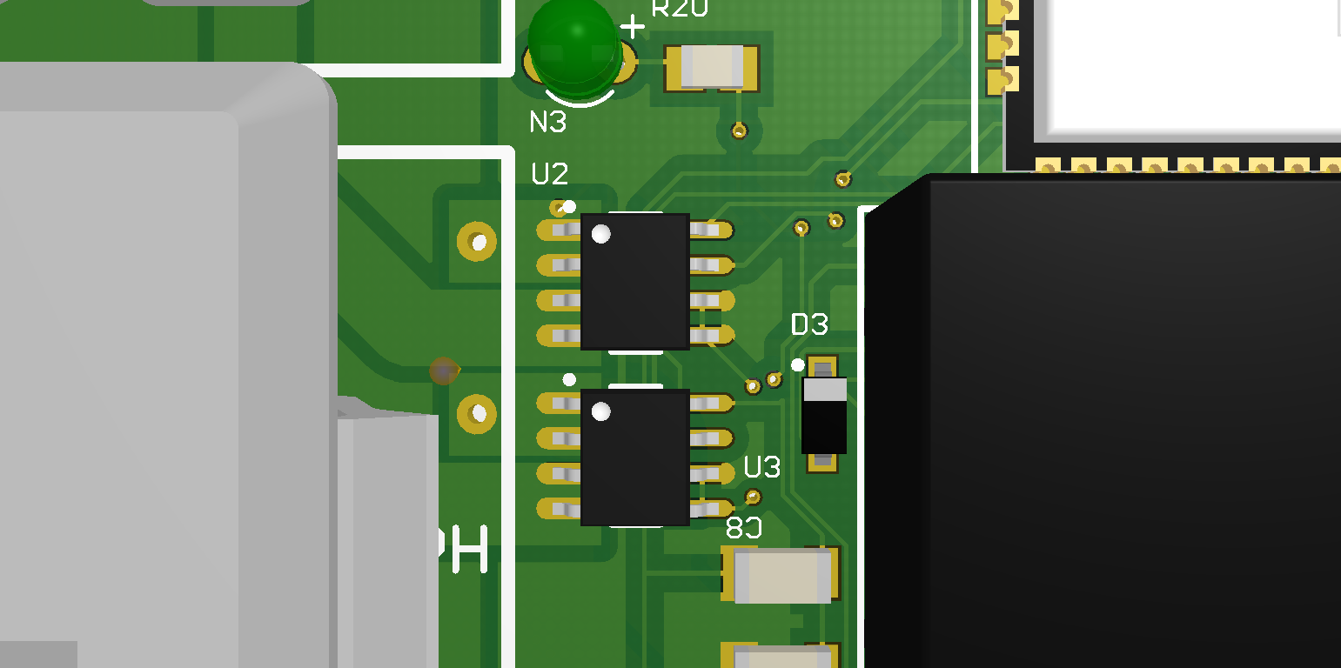

**Fig. 5**. Closeup of Current Sensor on PCB

Test Cases:

**Nominal Current**:

1. Connect the GND pin and the bit select pin to ground.
2. Apply 3.3 VDC to the VCC pin.
3. Connect the VIOUT pin to an ADC pin of a microcontoller. Take note of the reading it reports when there is no load attached. This is the zero-load bias we need to account for when taking later measurements.
4. Apply a load of 5A to the IP+ and IP- pins of the IC.
5. Subtract the zero-load bias we found earlier from the reported value. Afterwards, scale the result by the amount specified in the datasheet.

**PASS**: 5A +- 2% is being reported.